Sunny Patel

Cs281

Project 3

The following files are the components necessary to build a fully functioning single cycle processor. You will find all the code is documented and test benches are provided. The files have been checked for errors up to my knowledge. I actually end up creating structual models of these components in VHDL first and then behavioral which gave a better understanding of all the components and both modeling forms.

The testing approach that I took was drawing out the component, describing what each component should output on particular inputs and then writing the testbench accordingly. Here are the screenshots taken from the signal waves produced from these components:

This was the 32-bit ALU.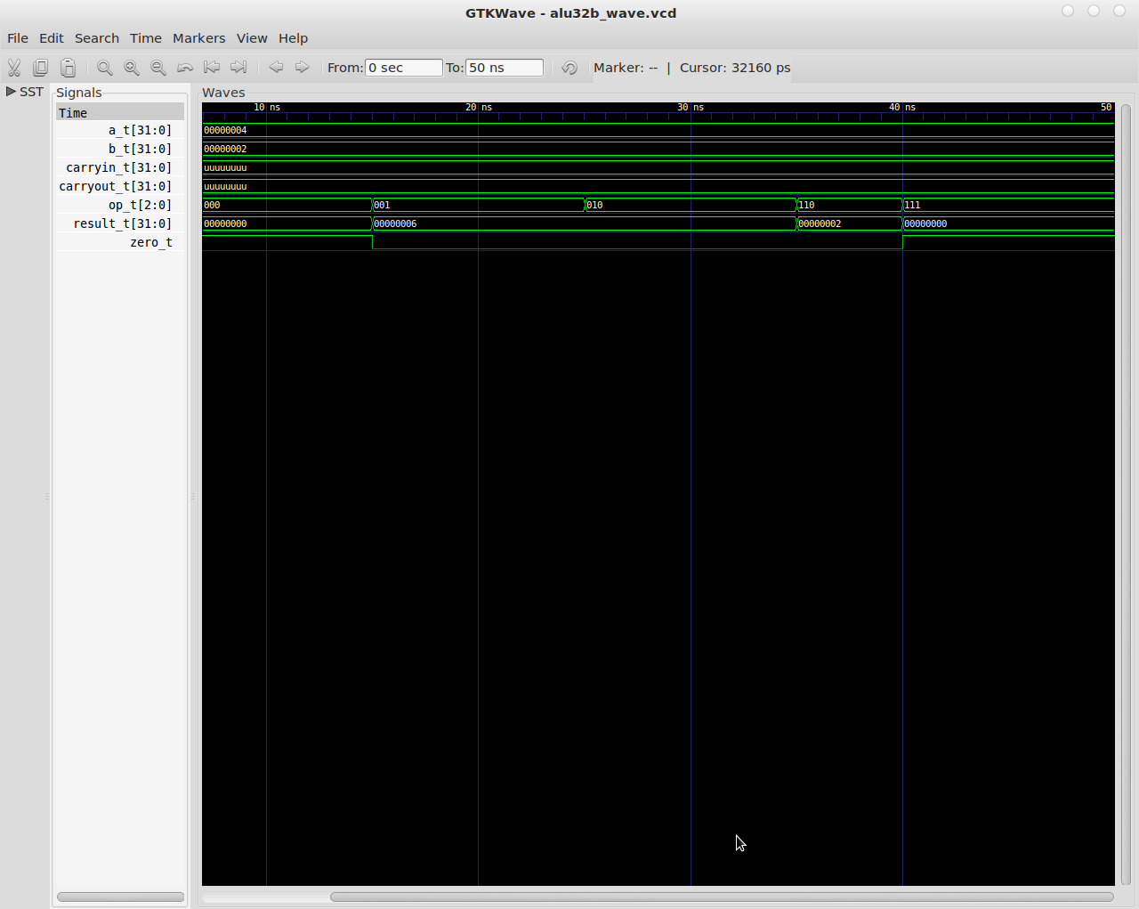

This was the memory component.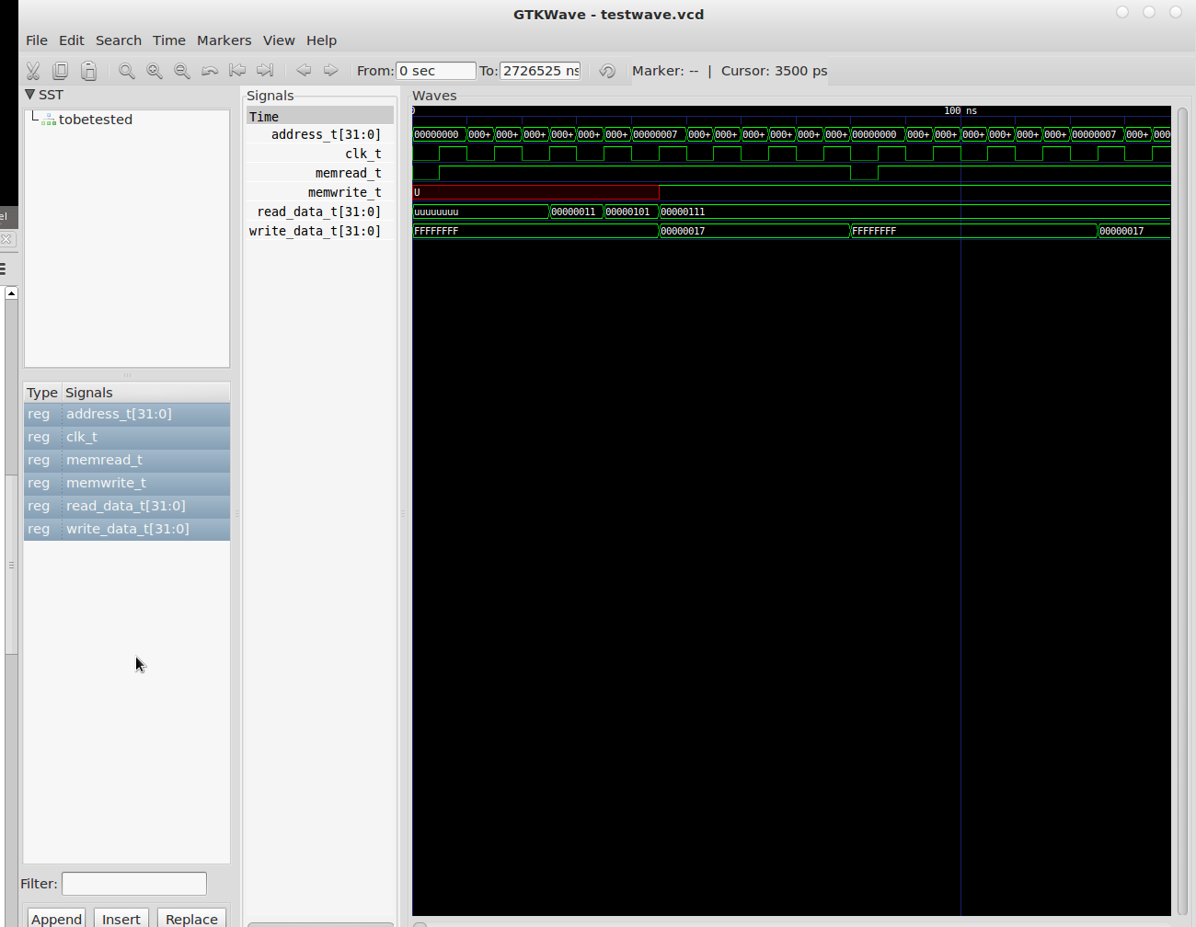

This is the register.